* Java identifiers are case sensitive
* pre-defined class can be used for Identifier

int Integer=10

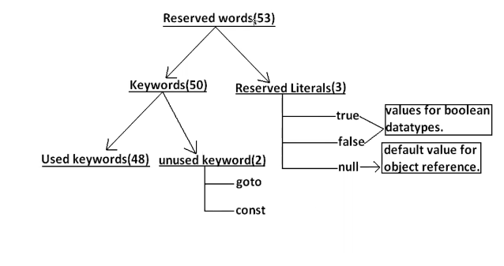

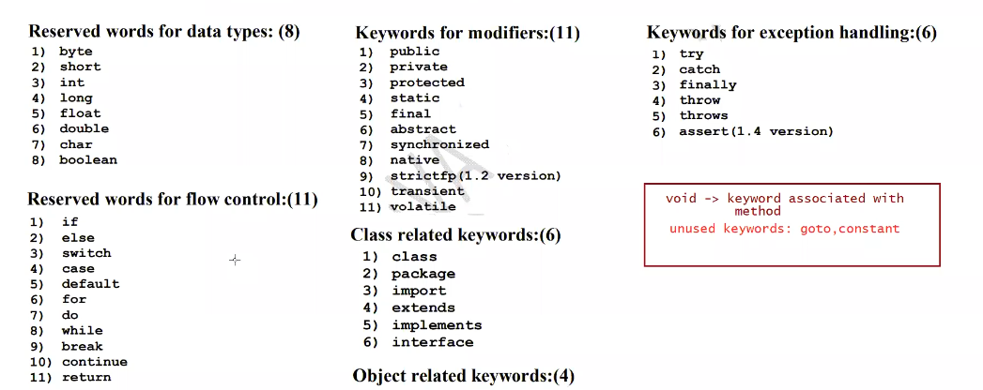

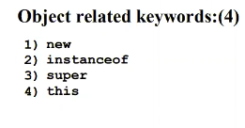

Java is strictly typed language : we need to tell the compiler what data type the variable will hold.

Literal : Any constant value that can be assigned to variable

int a=10

a--------------identifier

int----------------------Data Type

10-------------------------Literal

Reserved literals :

true

false

null

For boolean data-type reserved literals are true/false. Any value other than this would result in compile time error

Data Types:

Every variable has a type

Every Expression has a type.

Compiler Role : Compiler will check the value stored can be handled by data-type or not

This is called type-Cheking/Strictly type-Chekcing

int a=10

boolean result=true----Compiler will check whether the assigned variable can be stored in that data-type

Primitive Data types : Data which is commonly used and supported by any language to store directly.

a.Numeric Values

-----Real number

-----Whole number

b.Character Values

c.boolean values

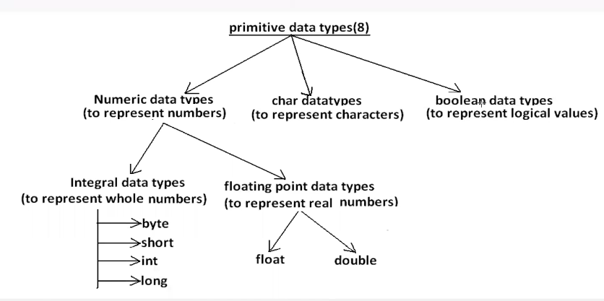

To store we have 4data-types

* byte
* short
* long
* int

size---How much memory is allocated to that data-type by JVM

Byte.SIZE----- We can know the size of Byte

Byte.MIN_VALUE ---Min Value that Byte can hold

Byte.MAX_VALUE ----Max Value that Byte datatype cna hold

byte a=25

byte b=135------------Compiler time error.

All reserved words start with lowercase.

Class/Interface names will start with Uppercase

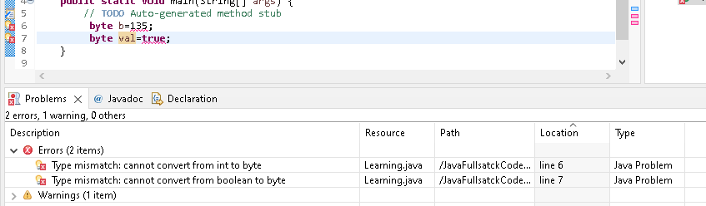

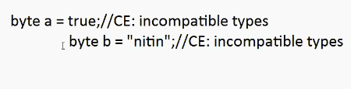

When to use byte data-type:

It is used when we handle the data which is coming from stream,network.

Short :

Short.SIZE ---- 2 BYTES

Short.MIN_VALUE ----- -32768

Short.MAX_VALUE ------ 32767

short data=137 –Valid

short data=32768

This data-type is not at all used and best suited for old processors like 8086

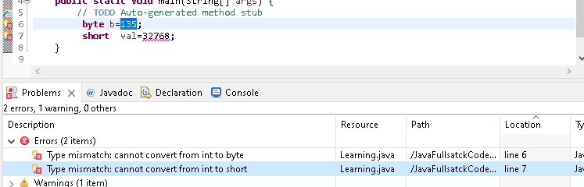

We will prefer the data-type which has capability to large values.

int –Default data-type used for storing integer values

int :

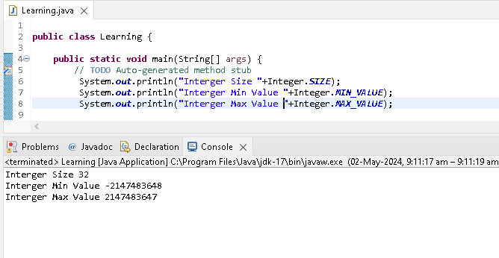

By default the whole numbers will be considered as int

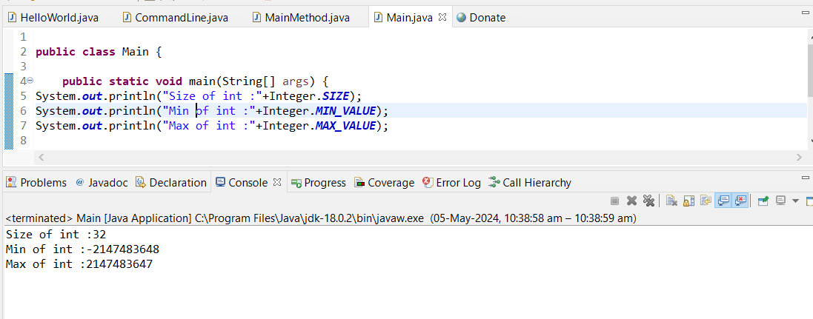

int val=true //in -Compatible types

If we specify any literal to the compiler. It will consider that literal as int.

Long:

8Bytes

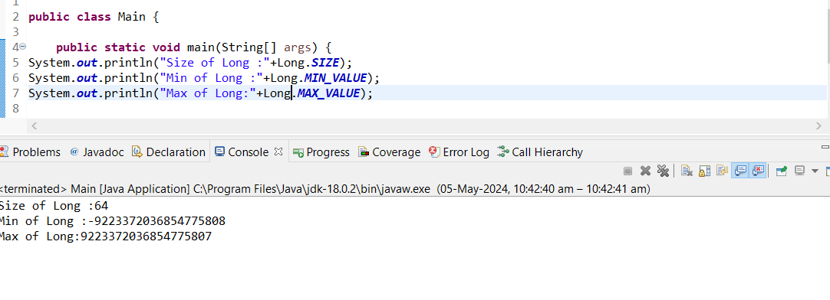

When we work with large files.data would be in GB’s .

When int is not enough to hold then we will go with a long datatype.

If the data goes beyond the integer range then we need to specify the literal with suffix ‘L’/’l’

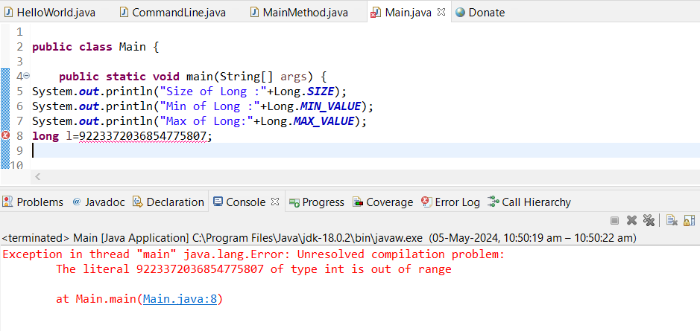

The literal value 9223372036854775807 cannot be treated as int as it out int range .In order to specify to compiler to treat as long we need put it with Suffix ‘L’/’l’/.Other wise it would result in compiler time Error.



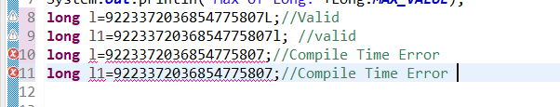

Even if the literal is within the integer range then also we can place the suffix ‘L’/’l’.

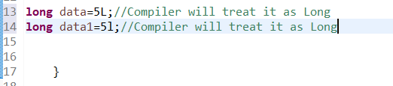

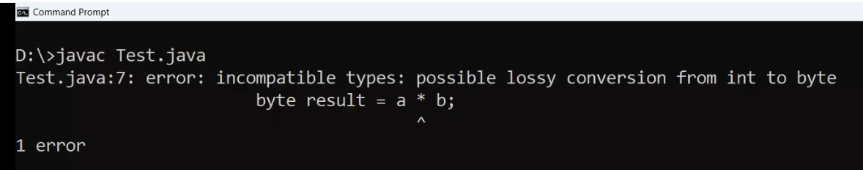

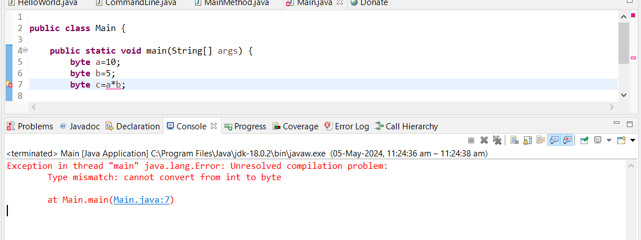

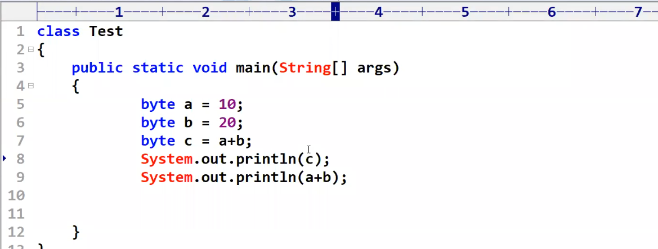

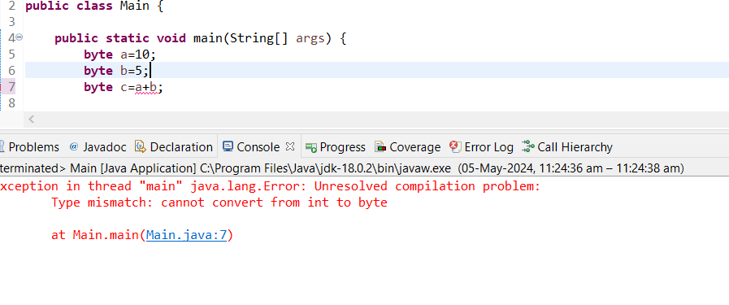

Type mismatch: Cannot convert int to byte.

long l1=54;

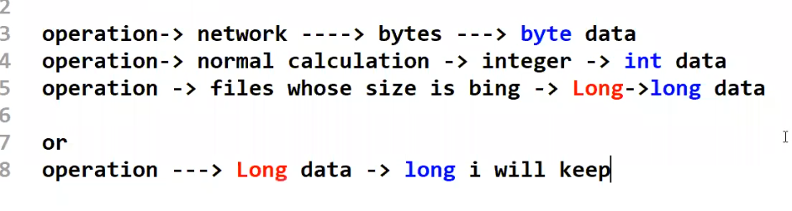

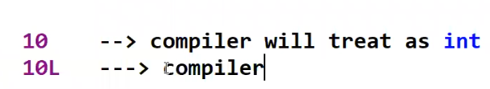

Compiler will treat 10L as long